Table 1, Basic characteristics of studies included

|  |  |  |  |  |  |  |  |  |  |  |
| --- | --- | --- | --- | --- | --- | --- | --- | --- | --- | --- |
| Author (Published Year) | Sample Type | Agea (years) | Stages I % | StagesI+II % | Gender (M/F) | Patients(M+/M-) | Control (M+/M-) | Methods | Aim | Multiple Targe |
| **Zhanget al (2011,China)b** | tissue | 59 | 32.05 | 74.36 | 29/39 | 44/34 | 10/68 | MSP | Diagnose | Yes |
| Wang et al (2008, China) | tissue | NA | NA | NA | 17/28 | 19/9 | 1/11 | 3-D PCR | Diagnose | Yes |
| Jin et al (2009, Japan) | tissue | 66.7 | NA | NA | 17/24 | 27/45 | 22/41 | MethyLight | Non-diagnose | Yes |
| Feng et al (2008, USA) | tissue | 64.3 | 42.86 | 78.00 | 26/49 | 26/23 | 21/28 | MethyLight | Diagnose | Yes |
| Brabender et al (2001, USA) | tissue | 63.3 | 49.45 | 70 | 69/91 | 86/5 | 80/11 | qRTPCR | Non-diagnose | SIngle |
| Virmani et al (2001, USA) | tissue | NA | NA | NA | NA | 22/26 | 0/18 | MSP | Diagnose | Yes |
| Yanagawa et al (2003, Japan) | tissue | 67.3 | 66.67 | 74.67 | 18/25 | 28/47 | 36/39 | MSP | Diagnose | Yes |
| Topaloglu et al (2004, USA) | tissue | NA | 54.84 | 83.87 | NA | 17/14 | 5/17 | qRTMSP | Diagnose | Yes |
| Kim et al (2007, Korea) | tissue | 63 | 56.57 | 74.00 | 64/79 | 48/41 | 33/66 | MSP | Non-diagnose | Yes |
| Vallbohmer et al (2006, USA) | tissue | 63 | 49.45 | 70.00 | 69/91 | 86/5 | 80/3 | PCR | Non-diagnose | Yes |
| Lin et al (2009, China) | tissue | 61.1 | 100.00 | 100.00 | 20/31 | 49/75 | 2/24 | MSP | Diagnose | Yes |
| Shivapurkar et al (2007, USA) | tissue | NA | NA | NA | NA | 35/5 | 23/17 | semiq RTPCR | Diagnose | Yes |
| Suzuki et al (2006, Japan) | tissue | 64 | 34.00 | NA | 33/49 | 53/97 | 3/57 | MSP | Non-diagnose | Yes |
| **Zhang et al (2011, China) b** | serum | NA | NA | 100 | NA | 54/56 | 5/45 | MSP | Diagnose | Yes |
| Pan et al (2009,China) | serum | 53 | NA | NA | 17/26 | 40/38 | 0/31 | RT-qMSP | Diagnose | Single |
| Begum et al (2011, USA) | serum | 65 | NA | 76 | 10/19 | 12/64 | 3/27 | qMSP | Diagnose | Yes |
| Rykova et al (2004, Russia) | serum | NA | NA | NA | NA | 3/6 | 0/16 | MSP | Diagnose | Yes |
| Usadel et al (2002, USA) | serum | 64.2+-9.6 | NA | NA | NA | 42/47 | 0/50 | RT-qMSP | Diagnose | Single |

Age, mean or median age from articles; Zhang et al (2011, China) b with two records since there are tissue and serum data simultaneously in this article.

Table 2 subgroup analysis for the main potential interference factors with random effect model

|  |  |  |  |  |  |  |
| --- | --- | --- | --- | --- | --- | --- |
|  | Study | OR | 95%CI | Q | I2 | Pvalue |
| **All** | 12 | 3.28 | 1.74-6.17 | 52.78 | 79.20% |  |
| Age≤ 64 | 6 | 4.65 | 2.17-9.93 | 15.42 | 67.60% |  |
| Age＞64 | 6 | 2.24 | 0.89-5.56 | 24.89 | 79.90% | 0.22 |
| Stage I≥49.45% | 5 | 4.11 | 1.90-8.91 | 12.76 | 68.60% |  |
| Stage I＜49.45% | 4 | 2.81 | 0.87-9.09 | 19.42 | 84.60% | 0.5944 |
| Stage(I+II) ≥75.33% | 5 | 2.45 | 0.98-6.12 | 26.69 | 85% |  |
| Stage(I+II)＜75.33% | 5 | 4.4 | 1.70-11.39 | 12.77 | 68.70% | 0.38 |
| M2F≤ 69.1% | 6 | 5.98 | 2.04-17.53 | 16.66 | 70% |  |
| M2F＞69.1% | 6 | 2.13 | 0.99-4.55 | 29.05 | 82.80% | 0.1246 |
| MSP | 8 | 5.16 | 2.01-13.26 | 44.61 | 84.30% |  |
| qMSP | 10 | 4.32 | 2.08-8.94 | 29.28 | 69.30% | 0.7685 |
| Diagnose | 13 | 6.79 | 2.99-15.44 | 59.54 | 79.80% |  |
| Non-diagnose | 5 | 2.59 | 1.33-5.05 | 11.56 | 65.40% | 0.0745 |
| Multiple | 15 | 4.08 | 2.28-7.34 | 62.99 | 77.80% |  |
| Single | 3 | 18.72 | 1.23-283 | 9.03 | 77.80% | 0.2836 |
| **heterogeneous** | **12** | **8.33** | **3.77-18.39** | **35.71** | **69.20%** |  |
| **autogenous** | **6** | **2.25** | **1.06-4.77** | **27.19** | **81.60%** | **0.0187** |
| Serum | 5 | 11.54 | 2.87-46.40 | 10.4 | 61.50% |  |
| Tissue | 13 | 3.72 | 2.03-6.78 | 55.18 | 78.30% | 0.14 |

K represent the number of the study in each subgroup; Pvalue shows the significance of the difference between groups

Table 3, significant association between APC methylation with adenocarcinoma rather than squamous cell carcinoma based on t-test with ? case ? control

|  |  |  |  |  |  |  |  |  |
| --- | --- | --- | --- | --- | --- | --- | --- | --- |
|  | Adenocarcinoma | | | | Squamous cell carcinoma | | | |
| CpG | Case  (N=304) | Control  (N=32) | p-value | **FDR** | Case  (N=323) | Control  N=86) | p-value | FDR |
| cg22791904 | 0.52 | 0.44 | 1.06e-10 | 1.28e-10 | 0.37 | 0.40 | 0.0042 | 0.0051 |
| cg08124027 | 0.25 | 0.12 | 7.50e-20 | 4.50e-19 | 0.13 | 0.09 | 0.00055 | 0.0011 |
| cg11724366 | 0.29 | 0.14 | 9.52e-18 | 2.86e-17 | 0.16 | 0.09 | 1.49E-07 | 8.95E-07 |
| cg05926837 | 0.34 | 0.21 | 1.89e-11 | 2.84e-11 | 0.21 | 0.17 | 0.0010 | 0.0016 |
| cg00318643 | 0.33 | 0.21 | 2.99e-07 | 2.99e-07 | 0.19 | 0.18 | 0.30 | 0.301 |
| cg20889774 | 0.26 | 0.16 | 5.58e-16 | 1.12e-15 | 0.16 | 0.13 | 0.00012 | 0.00036 |

Table 4, significant association between APC methylation with adenocarcinoma rather than squamous cell carcinoma based on t-test with ? case ? control

|  |  |  |  |  |  |  |  |  |
| --- | --- | --- | --- | --- | --- | --- | --- | --- |
|  | Adenocarcinoma | | | | squamous cell carcinoma | | | |
| cpgname | Ln(OR) | Pvalue | 95%CI | AUC | Ln(OR) | Pvalue | 95%CI | AUC |
| cg22791904 | 8.77 | 2.58E-05 | 4.84-13.07 | 0.78 | -1.81 | 0.10 | -4.01-0.363 | 0.591 |
| cg08124027 | 5.64 | 0.000389 | 2.81-9.11 | 0.69 | 2.24 | 0.14 | -0.44-5.65 | 0.559 |
| cg11724366 | 3.79 | 0.00114 | 1.71-6.35 | 0.66 | 2.38 | 0.011 | -0.683-4.42 | 0.514 |
| cg05926837 | 2.87 | 0.004713 | 1.00-5.03 | 0.64 | 1.20 | 0.123 | -0.25-2.82 | 0.528 |
| cg00318643 | 2.19 | 0.011982 | 0.58-4.03 | 0.64 | 0.23 | 0.72 | -0.99-1.55 | 0.546 |
| cg20889774 | 5.52 | 0.001262 | 2.44-9.23 | 0.67 | 2.22 | 0.061 | 0.039-4.72 | 0.533 |

Figure 1

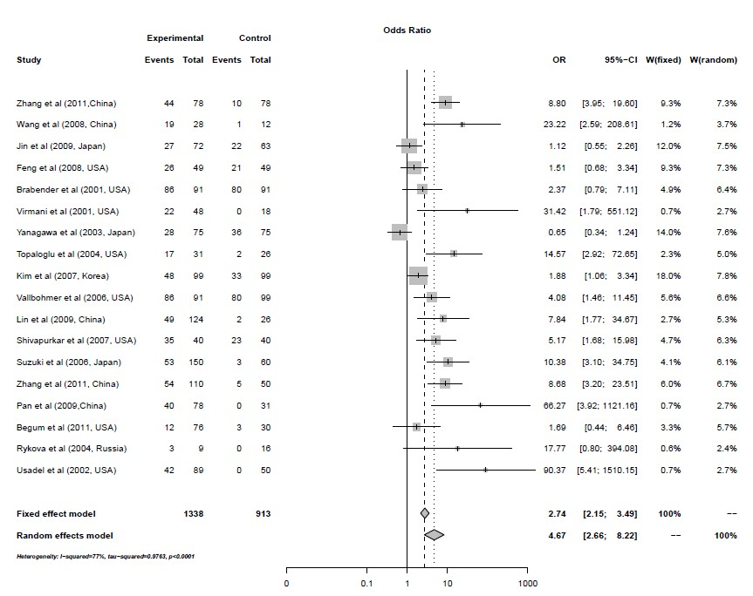

Figure 2

